Venue Visual Story for Progress Lab 1422 (PL1422)

INDEX

1. Information about Progress Lab 1422 3
2. Where is Progress Lab 1422? 4
3. Driving/Parking: 4
4. Bus 5
5. Entering the space 10
6. Inside the Progress Lab 1422 Building 11
7. Good Host 11
8. Box Office 14
9. Inside the Studio 15

Information about Progress Lab 1422

This event is happening at Progress Lab 1422. Here is a photo of the outside of the building.

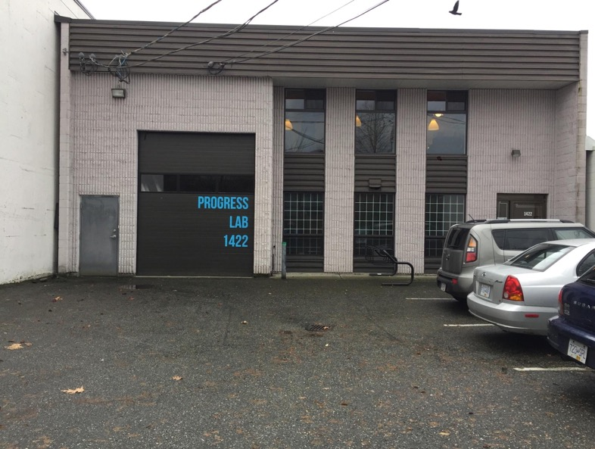

Where is Progress Lab 1422?

1422 William Street, Vancouver, BC View Google Map and Get Directions

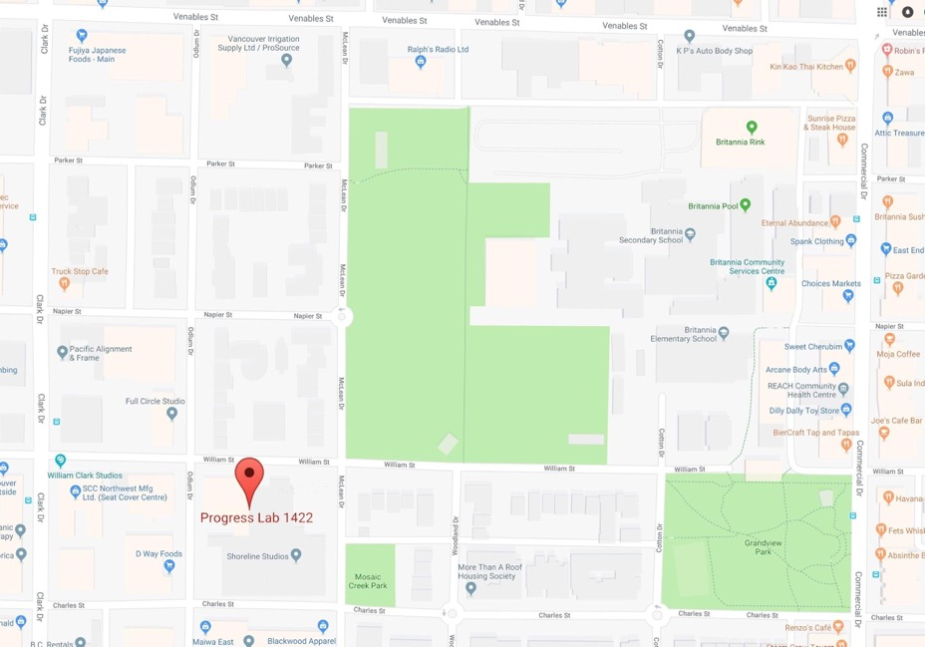

Driving/Parking:
The building is easiest to access from Clark Drive. Progress Lab 1422 is one and a half blocks east on William Street, just past Odlum Drive.

There is free parking on the street – on William Street or nearby Odlum Drive or McLean Drive.

Bus
The # 22 bus is within walking distance of the Progress Lab 1422 building.

This is what the 22 Southbound bus stop looks like.

It stops on Clark Drive right outside the Crème de la Crumb bakery cafe.

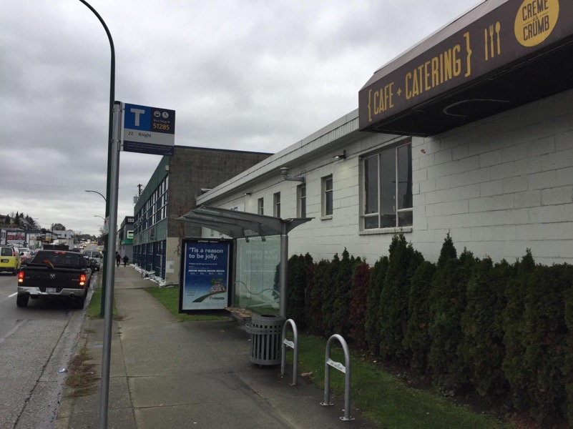

To walk to the Progress Lab 1422 building, cross Clark Drive at the light and walk one and a half blocks east on William Street.

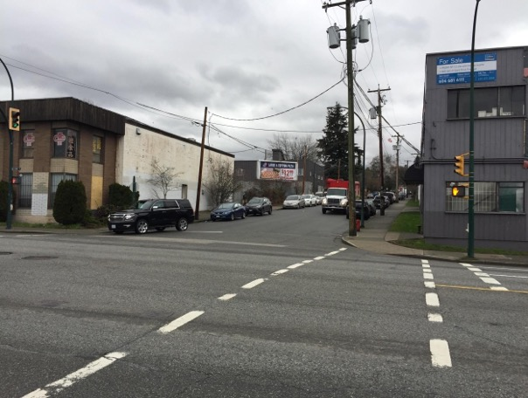

You will need to cross Odlum Drive and walk approximately half a block further.
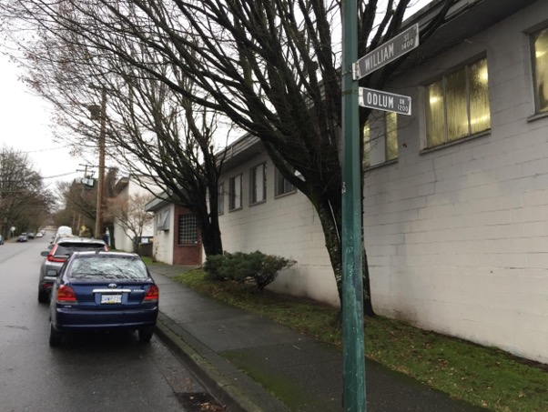

On your right, you will see the sign for Progress Lab 1422.

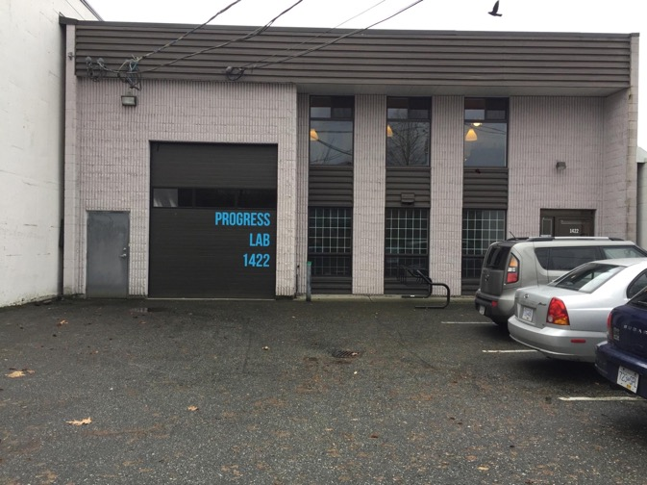

This is what the 22 Northbound bus stop looks like. It stops on Clark Drive.

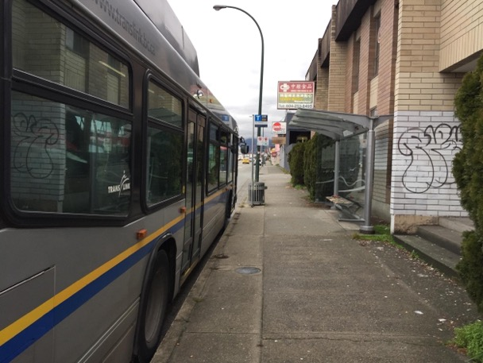

To walk to Progress Lab 1422, turn left at the corner of William Street and walk one and a half blocks east on William Street.
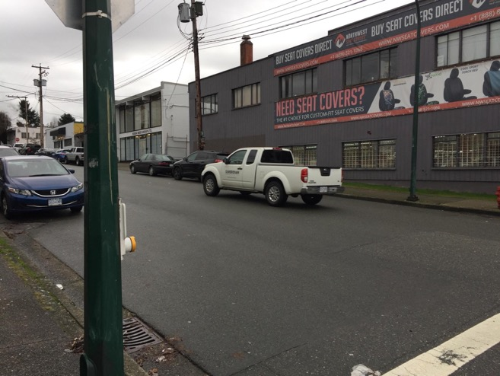

You will need to cross Odlum Drive then cross to the other side of William Street and walk approximately half a block further.
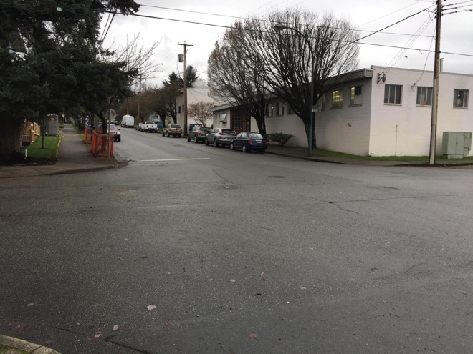
On your right, you will see the sign for Progress Lab 1422.
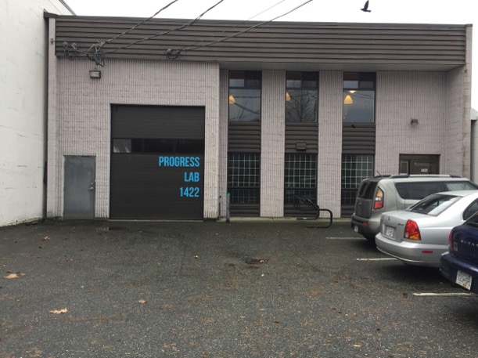

Entering the space

To enter the space on the night, you will enter through the garage doors.

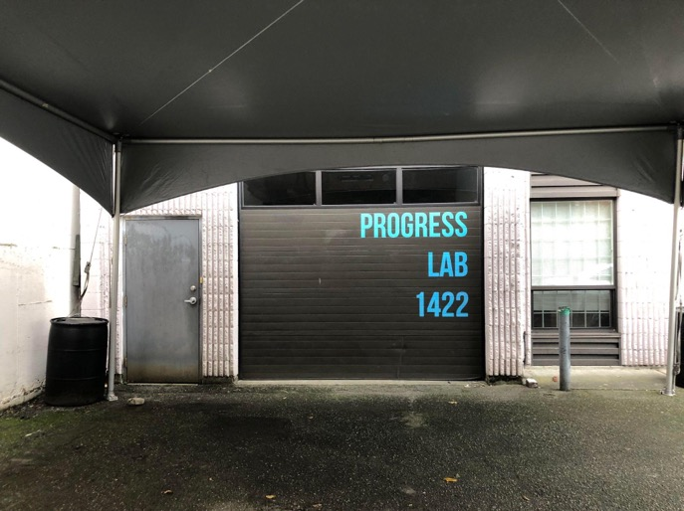

Then you will enter through a double door opening to the inside of Progress Lab 1422.

Inside the Progress Lab 1422 Building
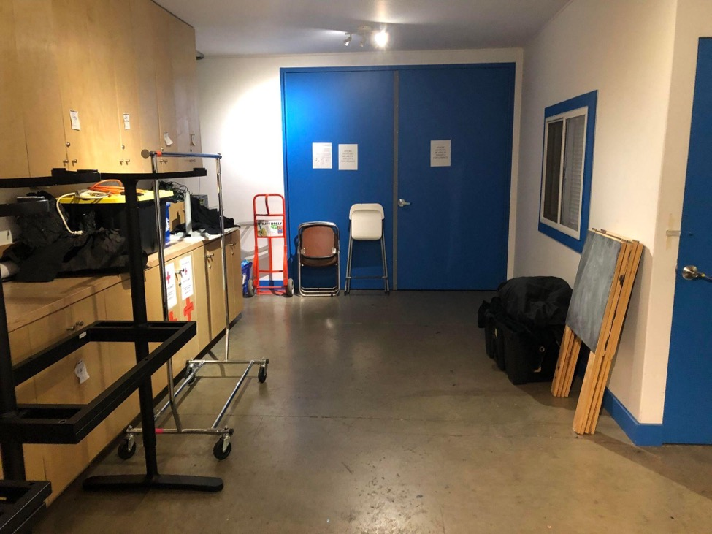

Good Host

Pi and Rumble are pleased to offer Good Host services for this production.

Look for the person in a bow tie and ballcap with a name tag that reads Good Host or ask someone to take you to them.

What a Good Host does

A Good Host welcomes people into the space, shows them around if they haven’t been there before - The Good Host can introduce you to others if you feel like meeting someone new in the lobby and they can leave you alone if you don’t. The Good Host can also answer any questions about seating, content and sensory warnings and any other concerns. If they don’t have an answer, they’ll tell you that. The Good host is also available for any accessibility needs, if the Good Host is not at the door to welcome you in, they may be with someone else.

Look for the person in a bow tie and ballcap with a name tag that reads Good Host or ask someone to take you to them.

The Good host would also be the person to contact before coming to the show, if you’d like to be met at a bus stop and guided to the theatre. Contact goodhost@rumble.org for any questions about this or any other curiosities about the Good Host.
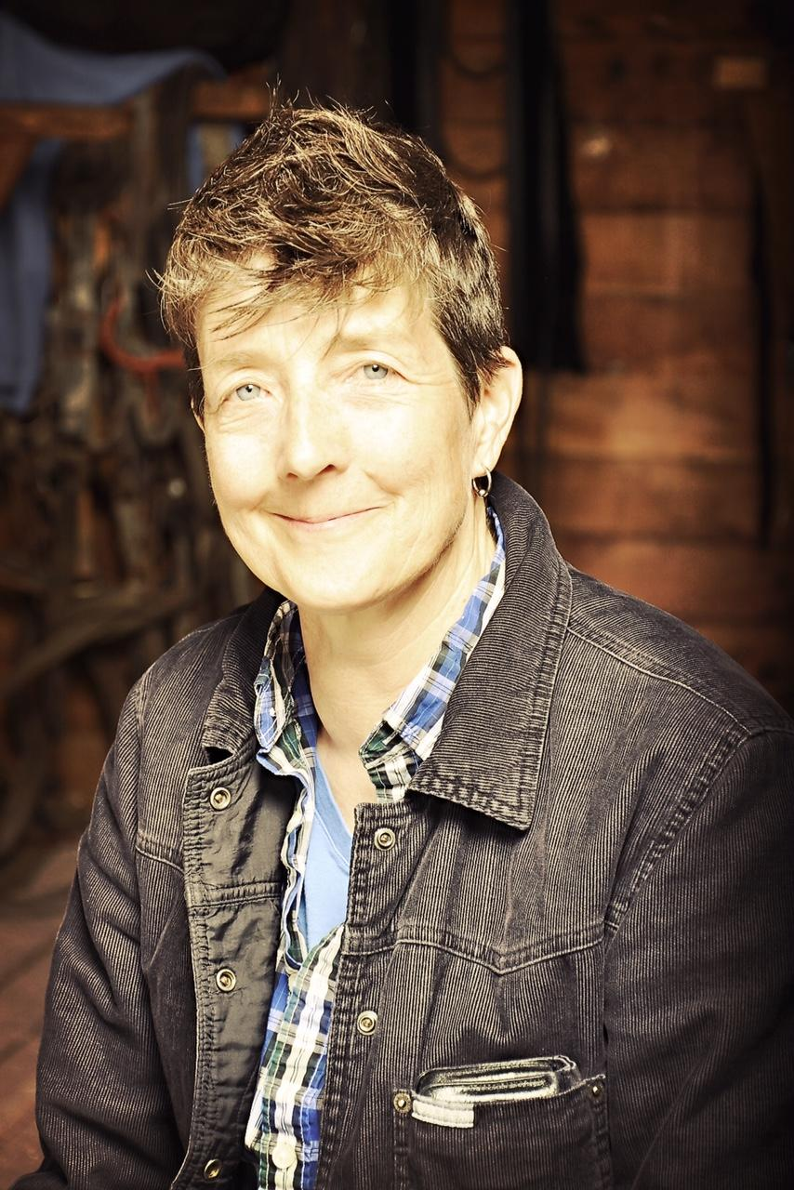
This is a photo of the Good Host.

Box Office

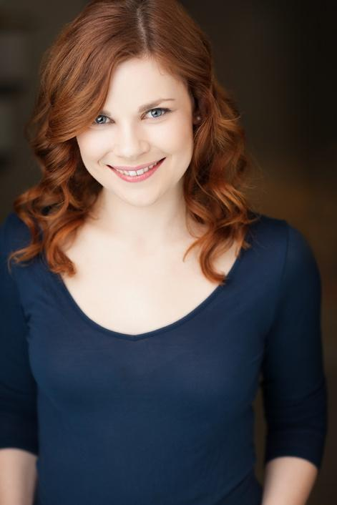

This is a photo of Libby. She will check you in at Box Office.

Look for Libby when you arrive at Progress Lab - no need to bring a printed ticket, she'll just check you off a list! As well, Libby is the person to ask if you have any questions or concerns about your ticket, and you can also come to her with any other questions you have related to the event or the venue.

You can contact Libby at libby@pitheatre.com

Inside the Studio

The event will happen in the Studio space which is located at the end of the hallway.

This is what the Studio space looks like inside.

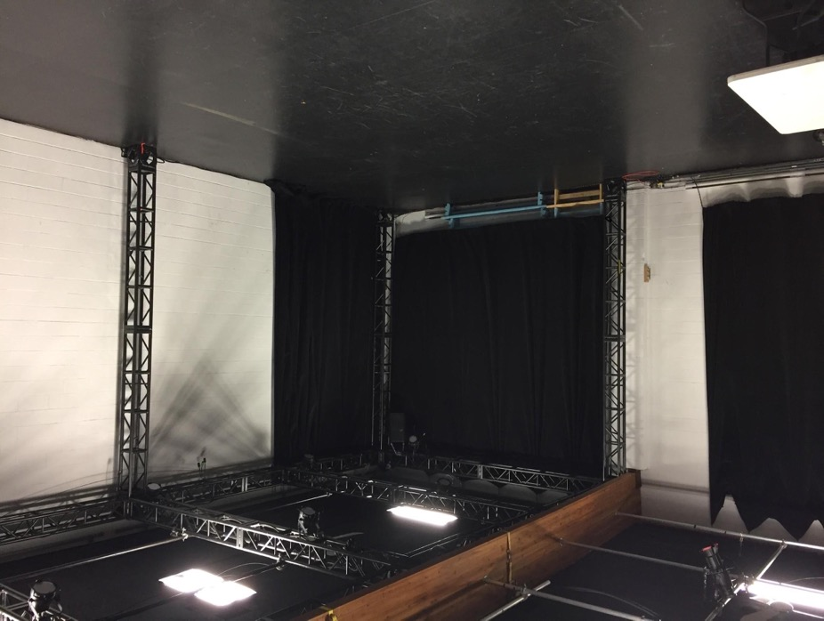

- Washrooms

In the hallway, there are three washrooms. The one on the far left is an accessible washroom. All three washrooms are gender neutral.

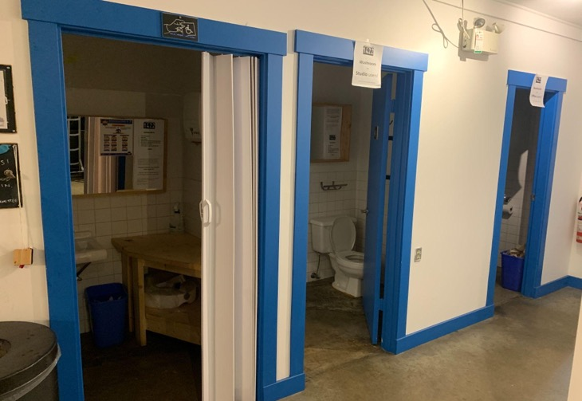

This Visual story is based on one originally created by Neworld Theatre for the LEAD Ensemble, we thank them for their support.

