Venue Visual Story for Tremors 2023 at Progress Lab 1422 (PL1422)

INDEX

Information about Progress Lab 1422 3
Where is Progress Lab 1422? 4
Driving/Parking: 4
Bus 5
Inside the Progress Lab 1422 Building 9
Inside the Studio 10
Kitchen 12

Information about Progress Lab 1422
This event is happening at Progress Lab 1422. Here is a photo of the outside of the building.

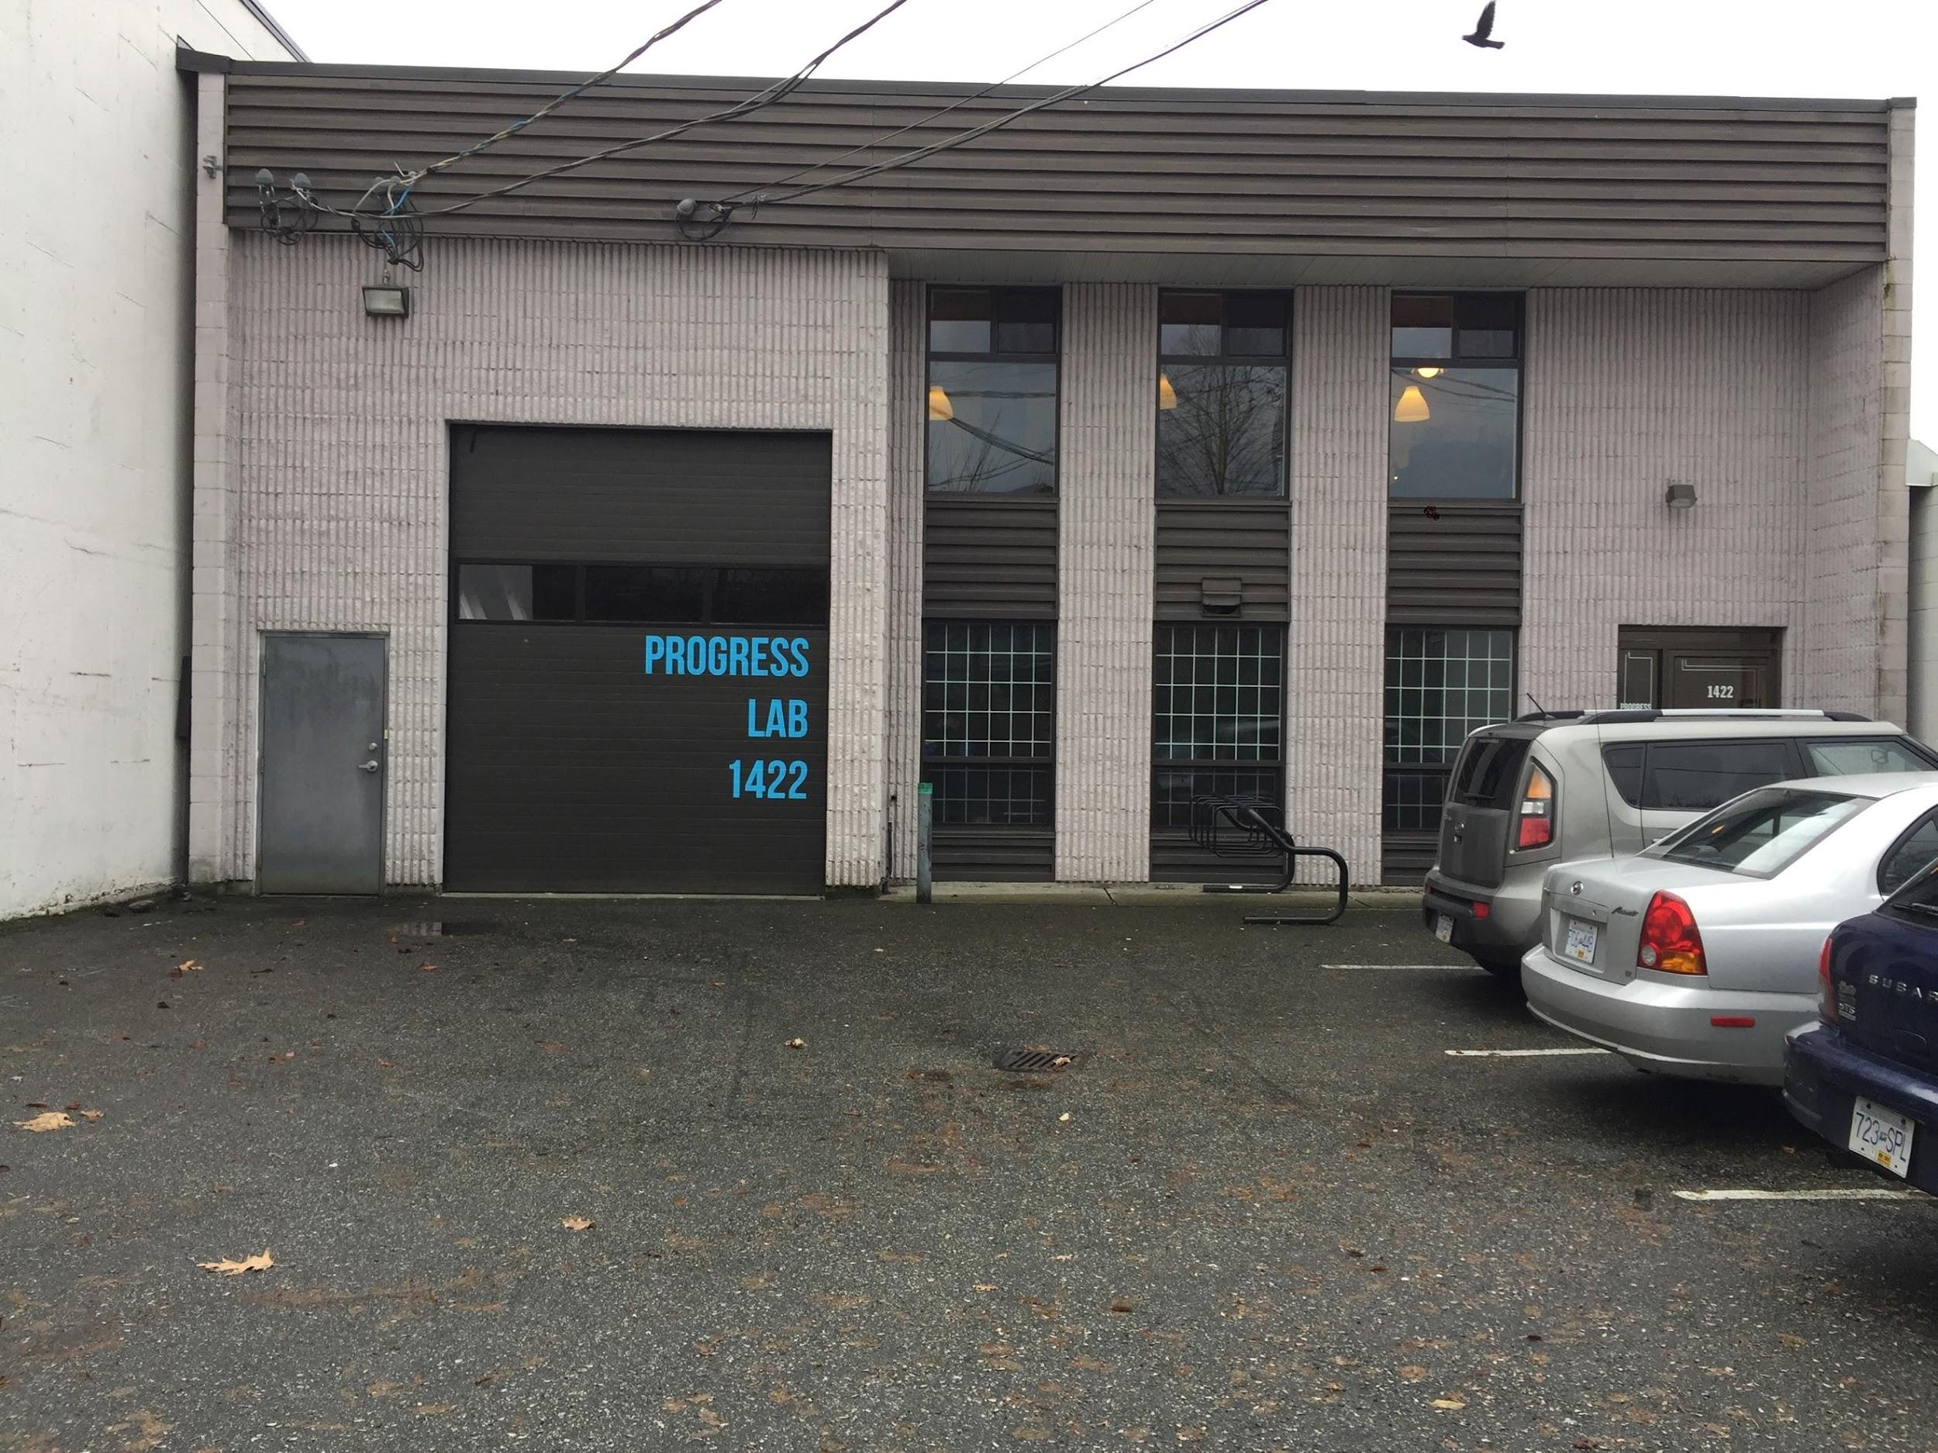

Where is Progress Lab 1422?

1422 William Street, Vancouver, BC View Google Map and Get Directions

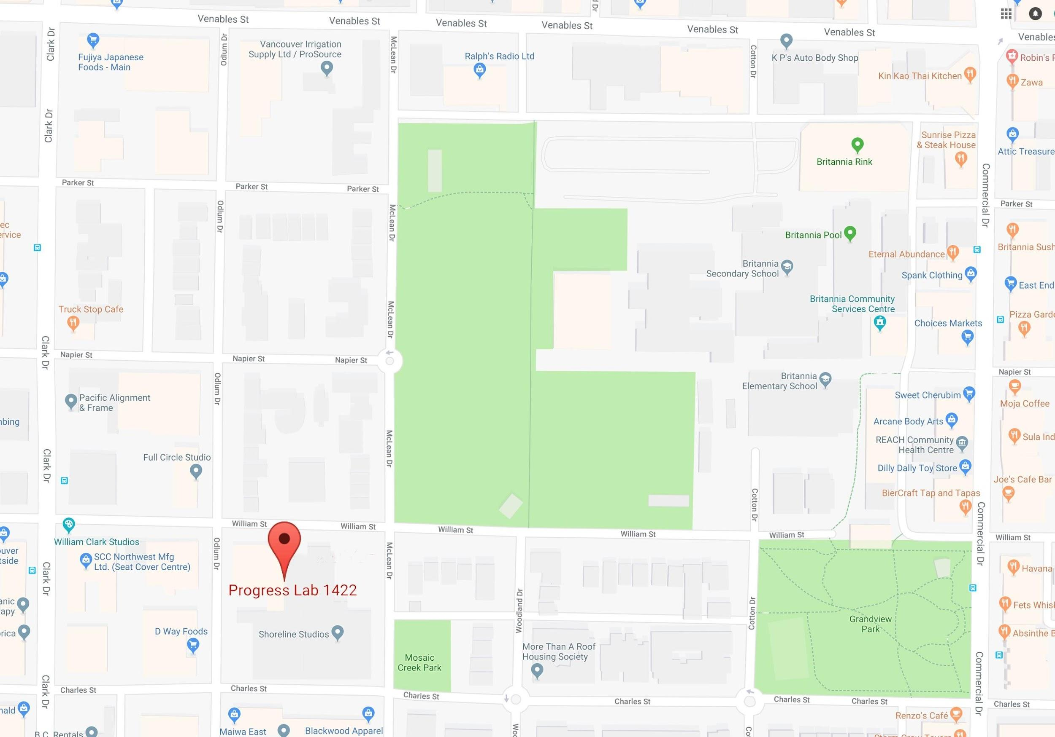

Driving/Parking:
The building is easiest to access from Clark Drive. Progress Lab 1422 is one and a half blocks east on William Street, just past Odlum Drive.

There is free parking on the street – on William Street or nearby Odlum Drive or McLean Drive.

Bus
The # 22 bus is within walking distance of the Progress Lab 1422 building.

This is what the 22 Southbound bus stop looks like.

It stops on Clark Drive right outside the Crème de la Crumb bakery cafe.

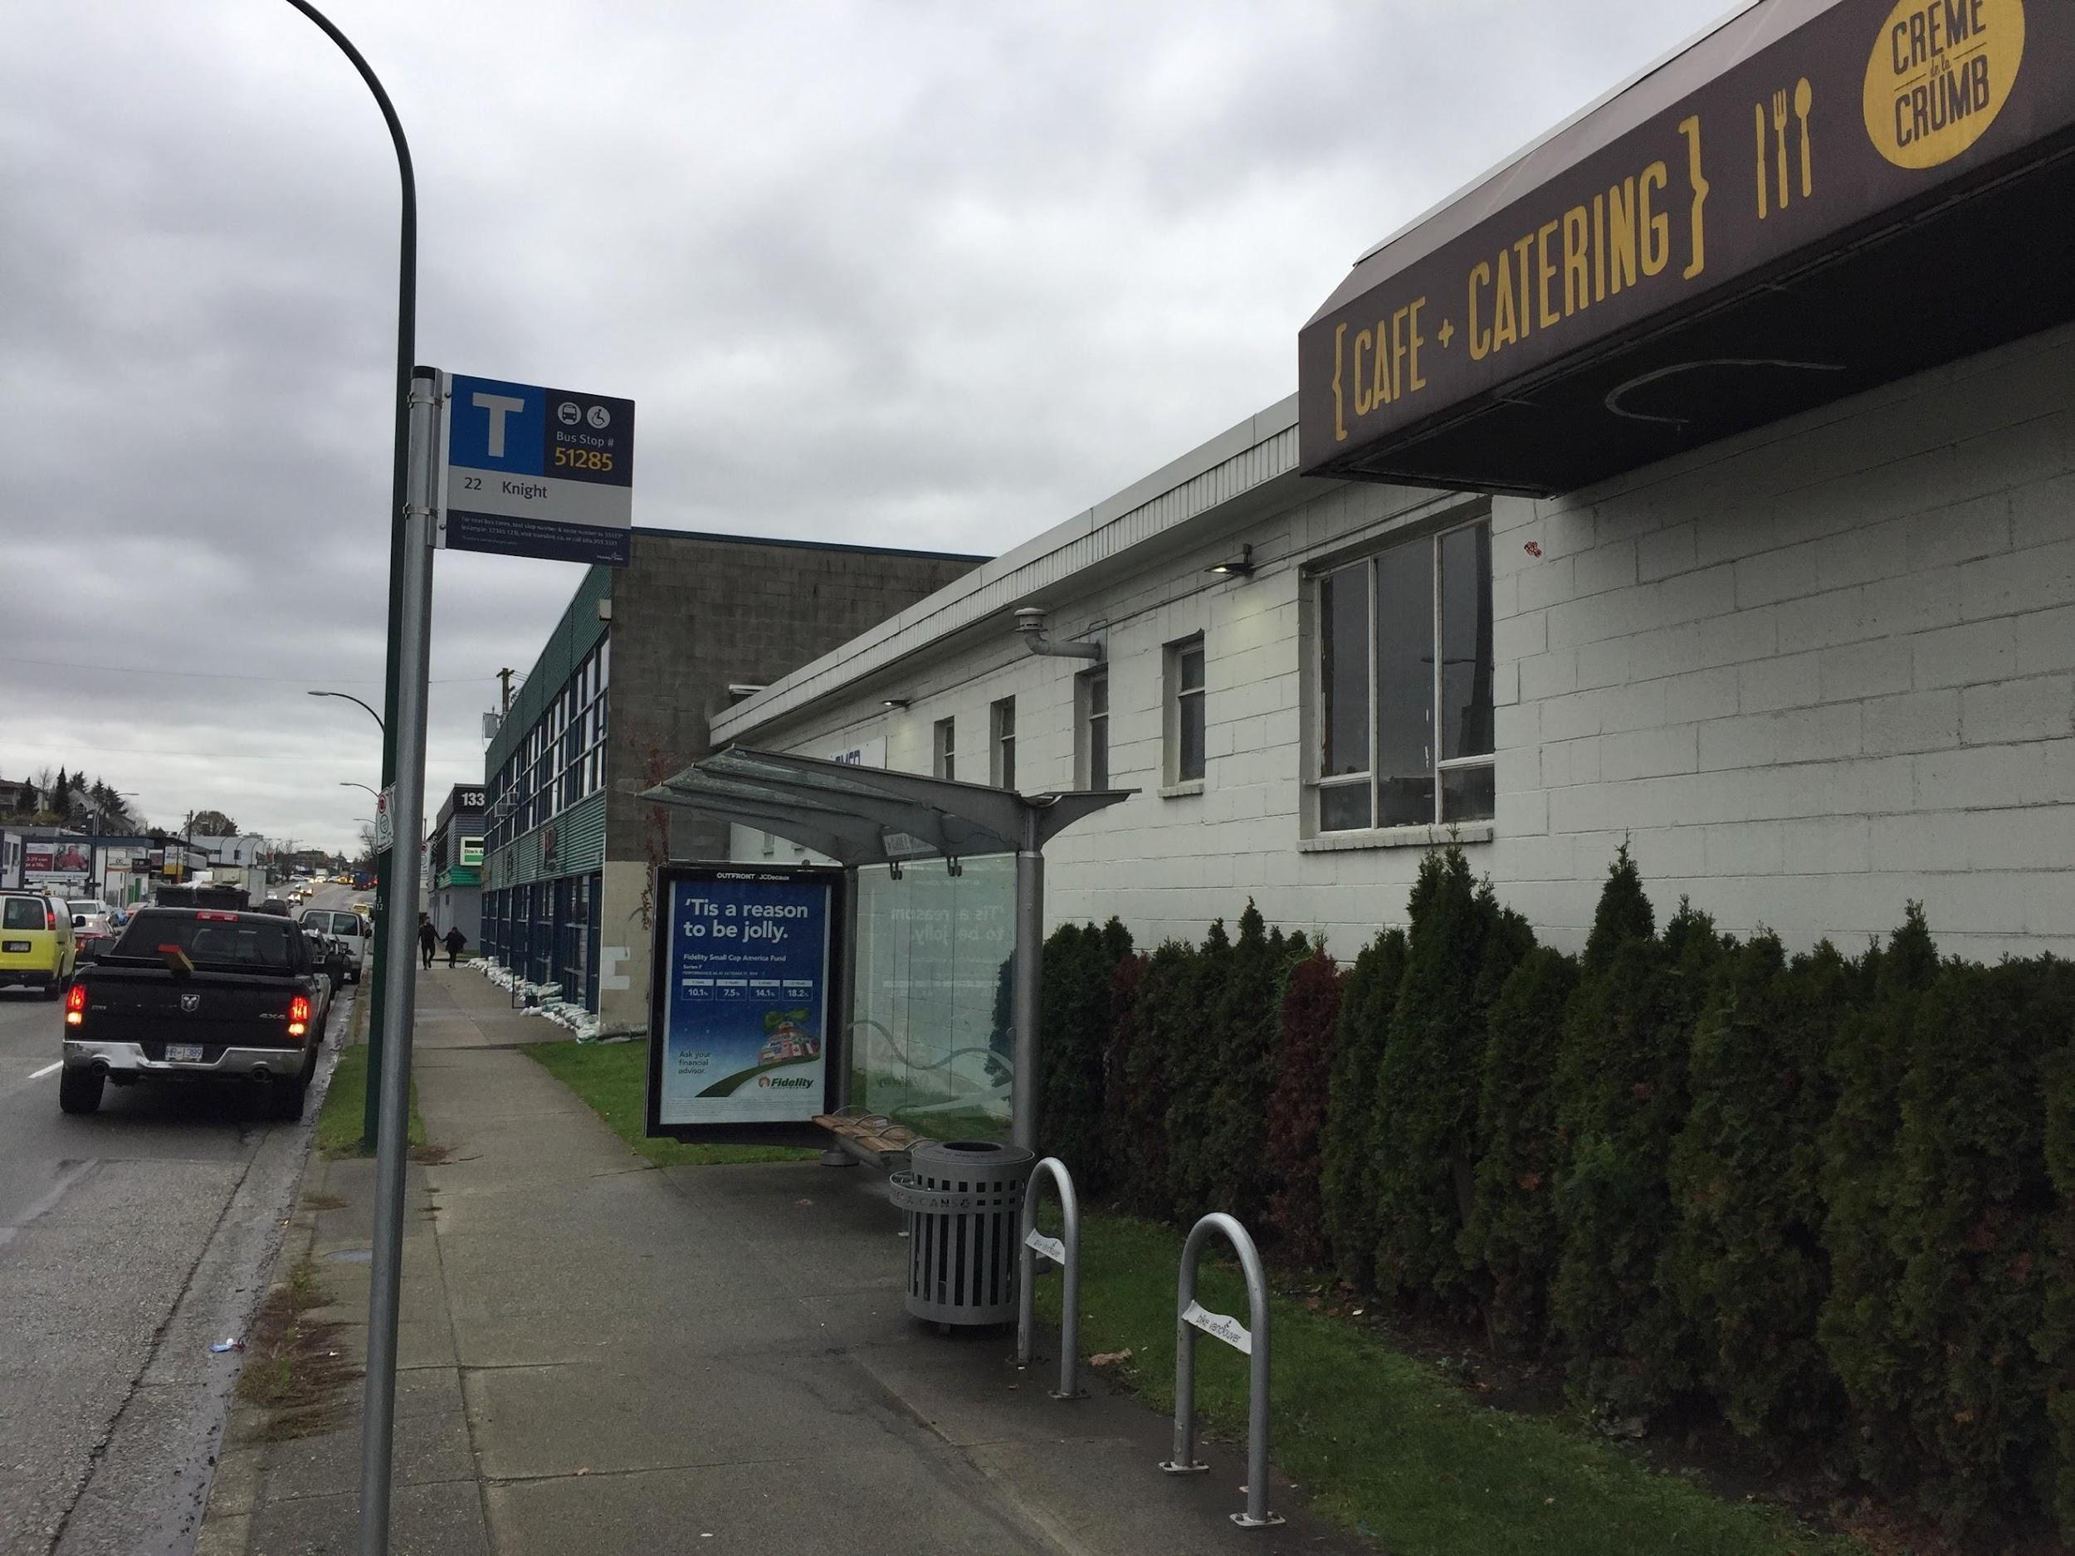

To walk to the Progress Lab 1422 building, cross Clark Drive at the light and walk one and a half blocks east on William Street.

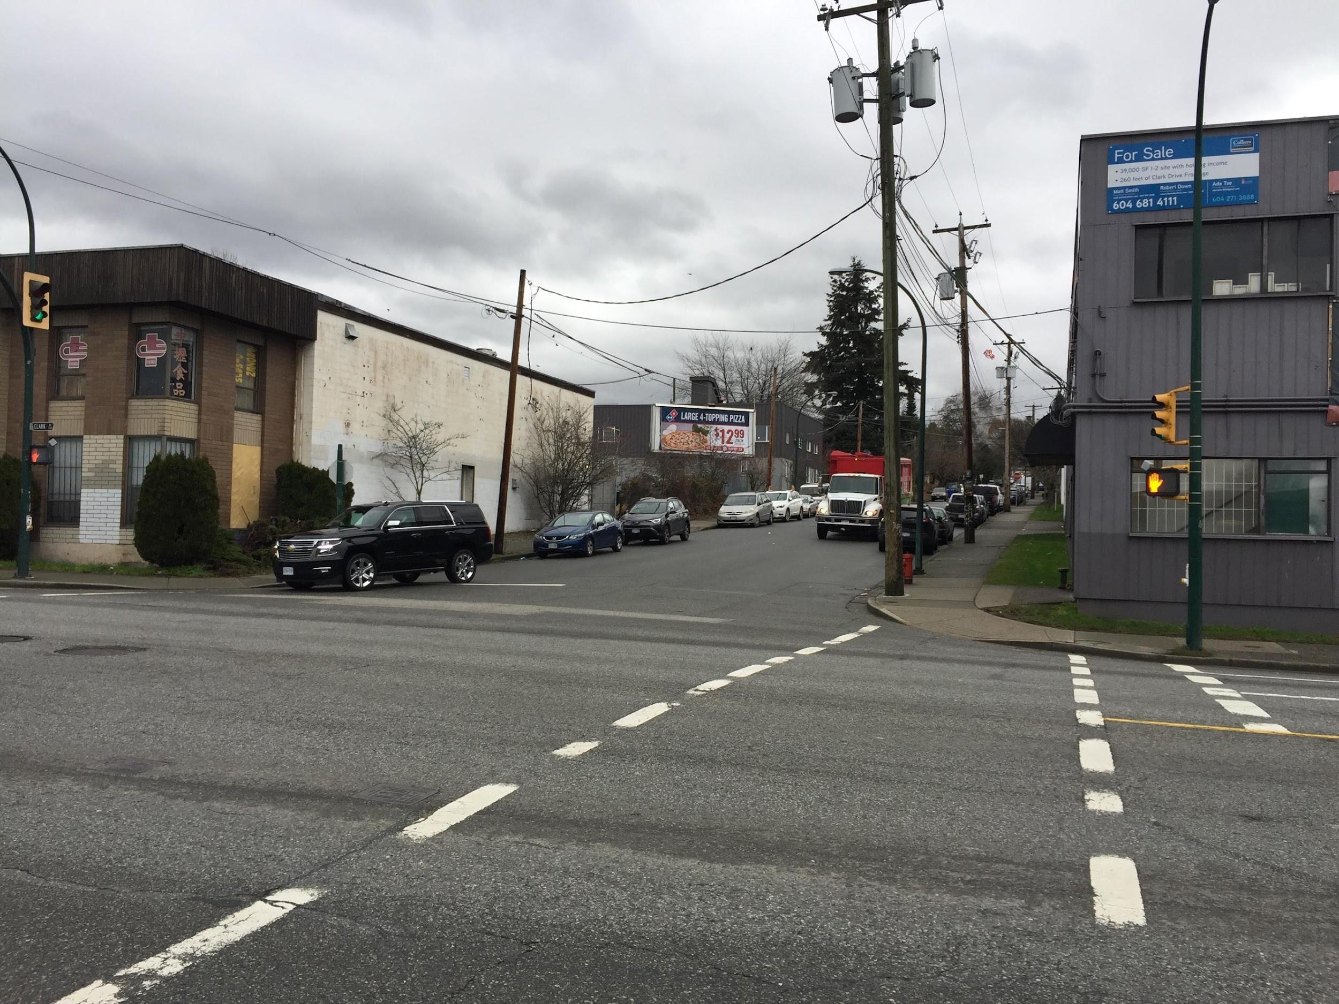

You will need to cross Odlum Drive and walk approximately half a block further.
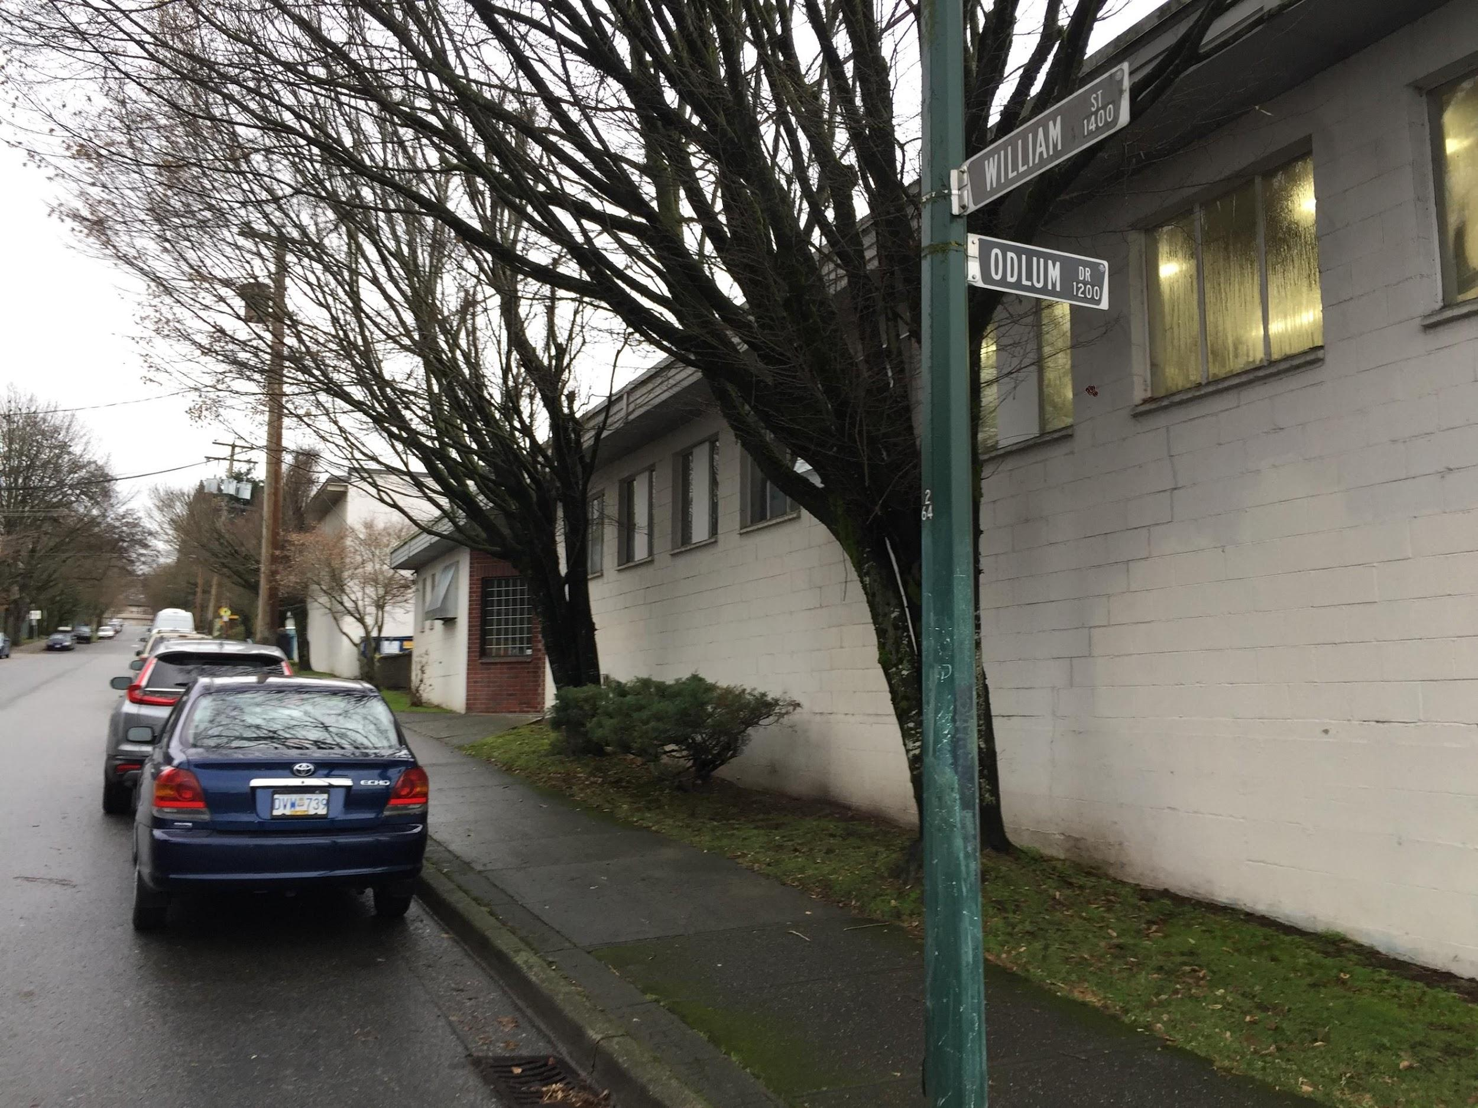

On your right, you will see the sign for Progress Lab 1422.

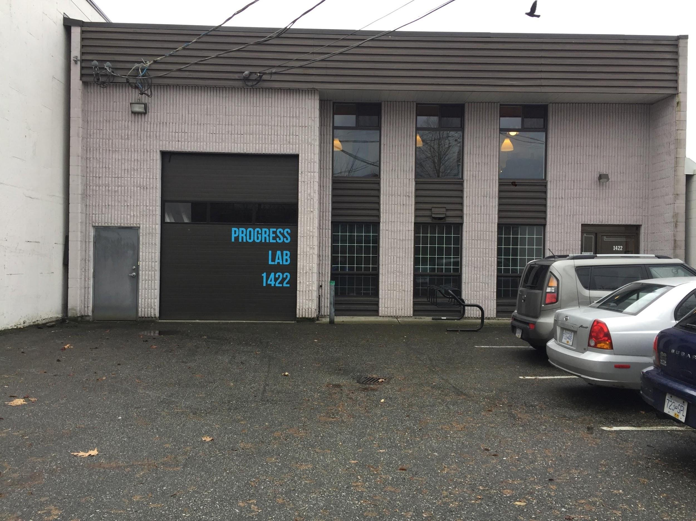

This is what the 22 Northbound bus stop looks like. It stops on Clark Drive.

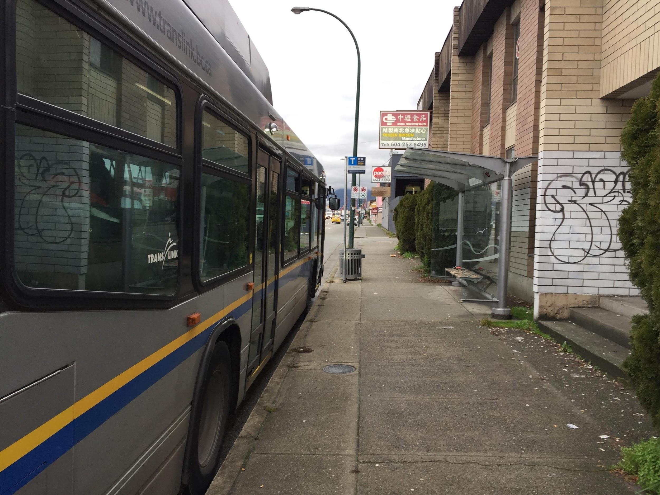

To walk to Progress Lab 1422, turn left at the corner of William Street and walk one and a half blocks east on William Street.
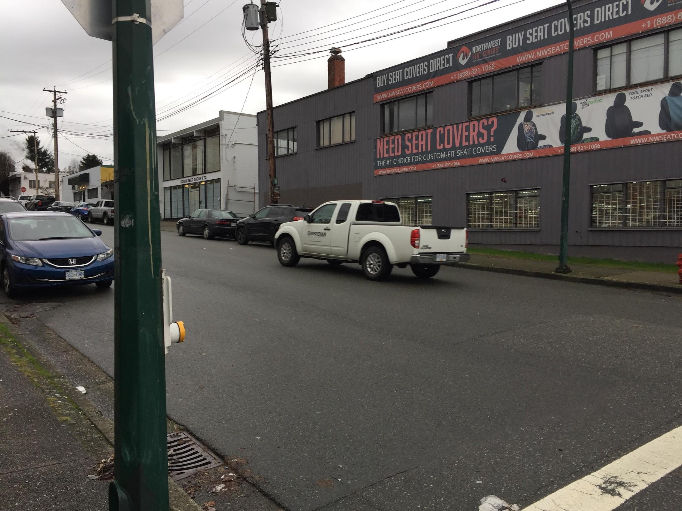

You will need to cross Odlum Drive then cross to the other side of William Street and walk approximately half a block further.
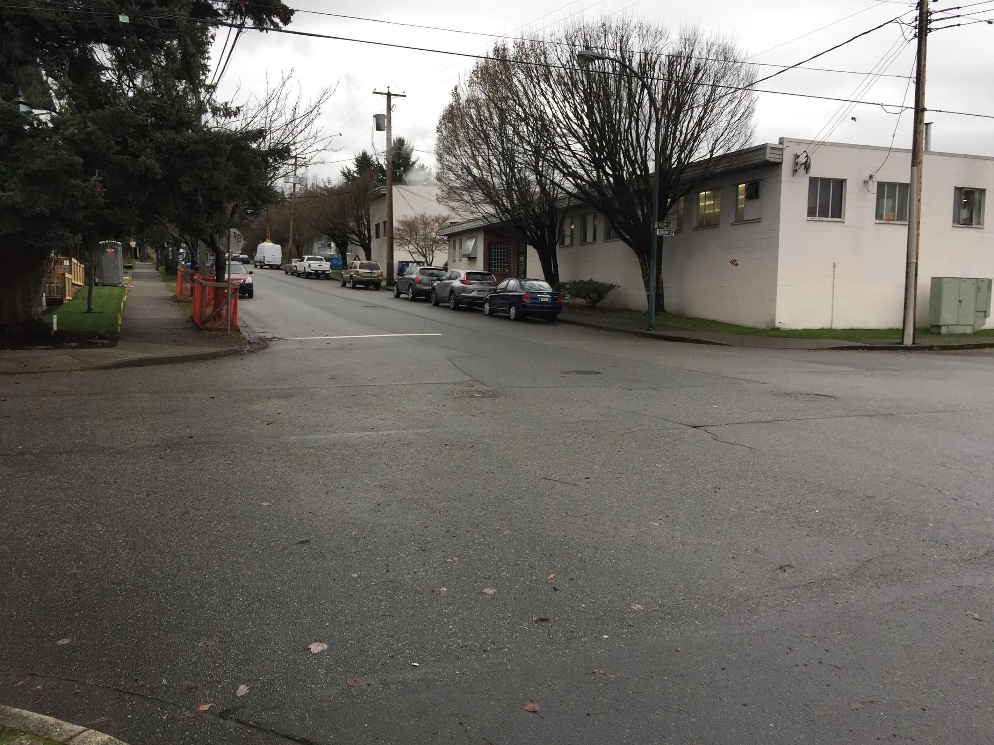
On your right, you will see the sign for Progress Lab 1422.
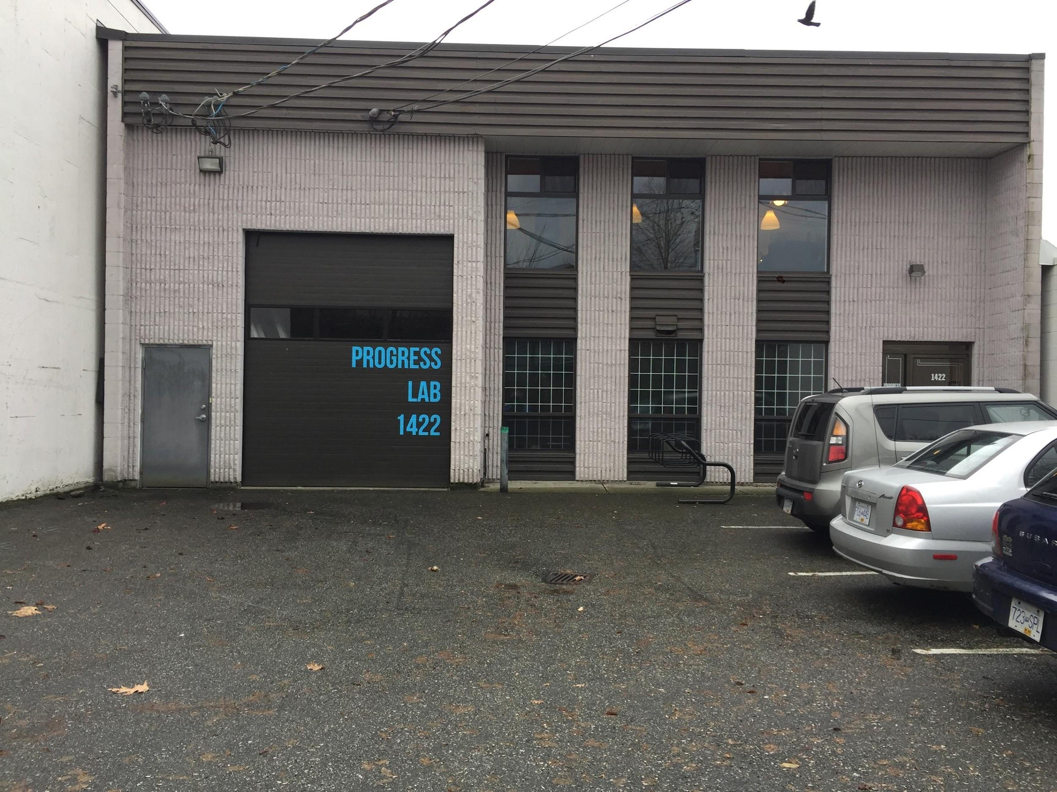

Entering the space

To enter the space on the night, you will enter doors on the right by the intercom.

Then you will enter through a double door opening to the inside of Progress Lab 1422.
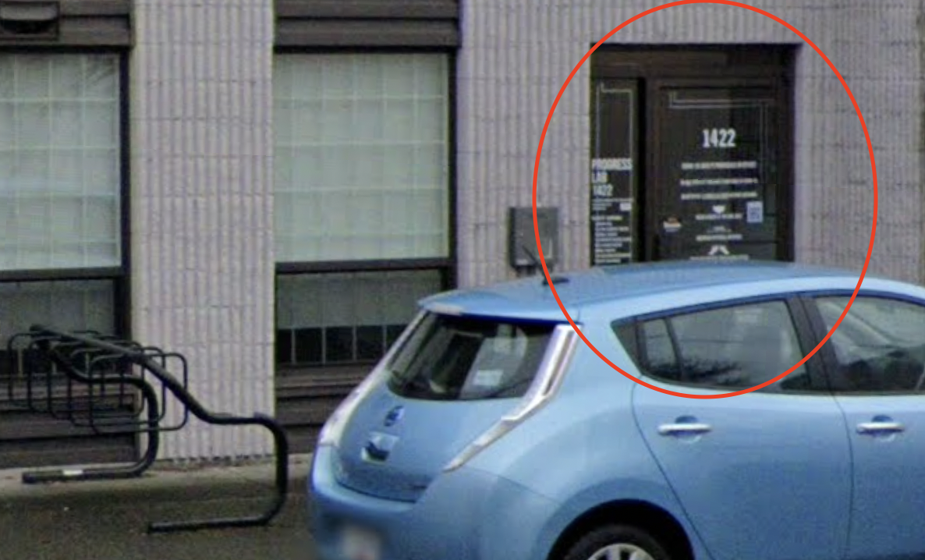

Inside the Progress Lab 1422 Building
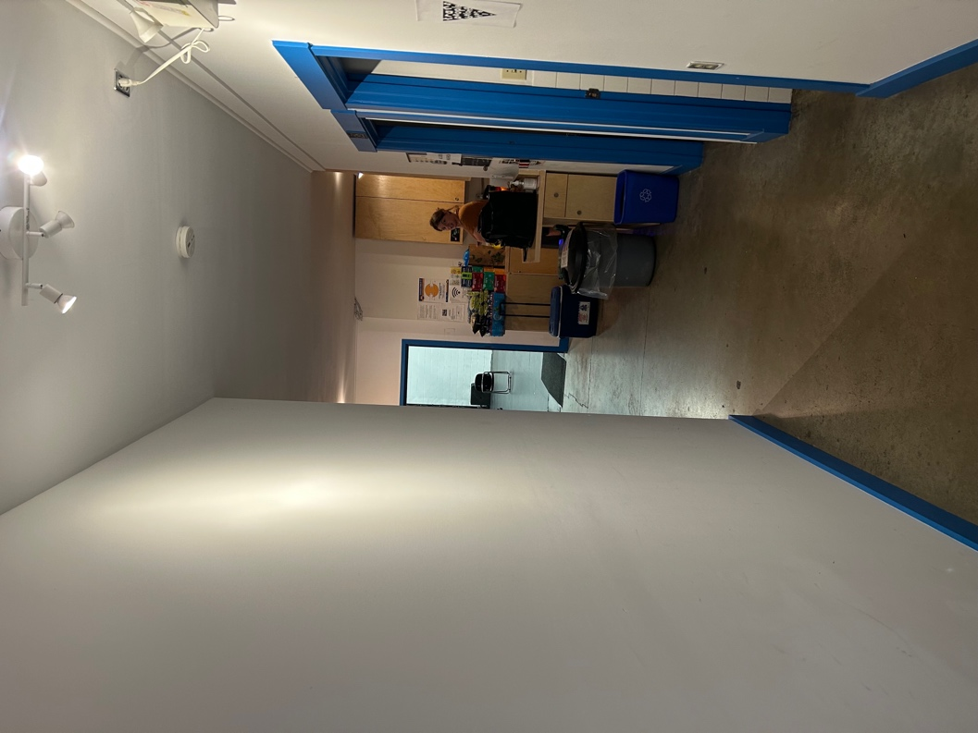

This is the hallway past that door.

In front is the studio where some performances will be taking place.

To the left is the gathering area where you can hang out with people!

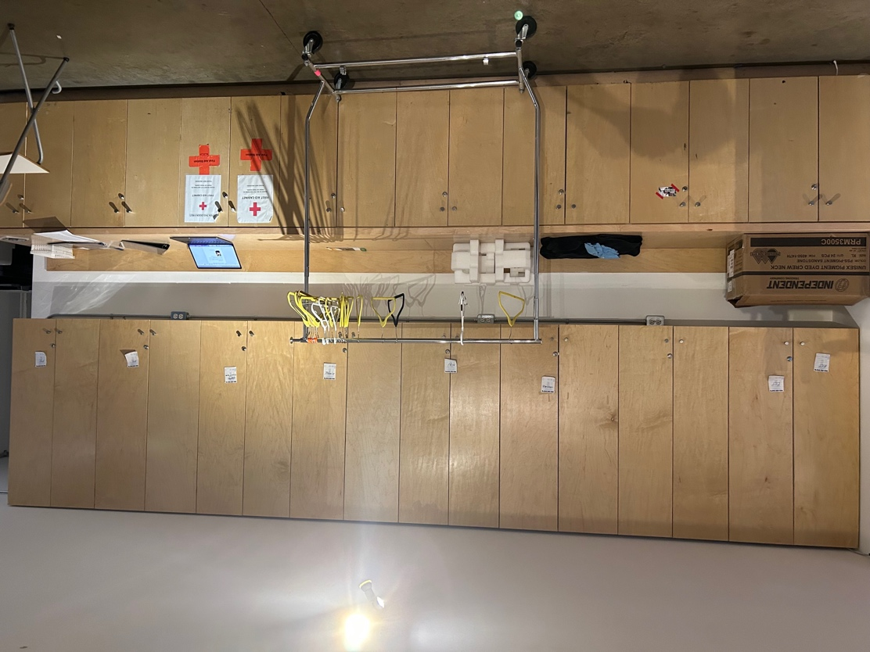

- Track Leaders

Tremors Festival will feature a track system, leading you through 4 performances per night.

There are 2 track leaders to guide you through the building to your next performance.

This is Garvin – One of the track leaders.

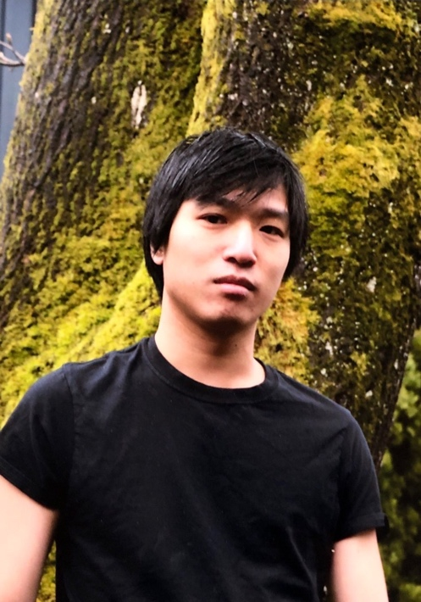

This is Anna – The other track leader.

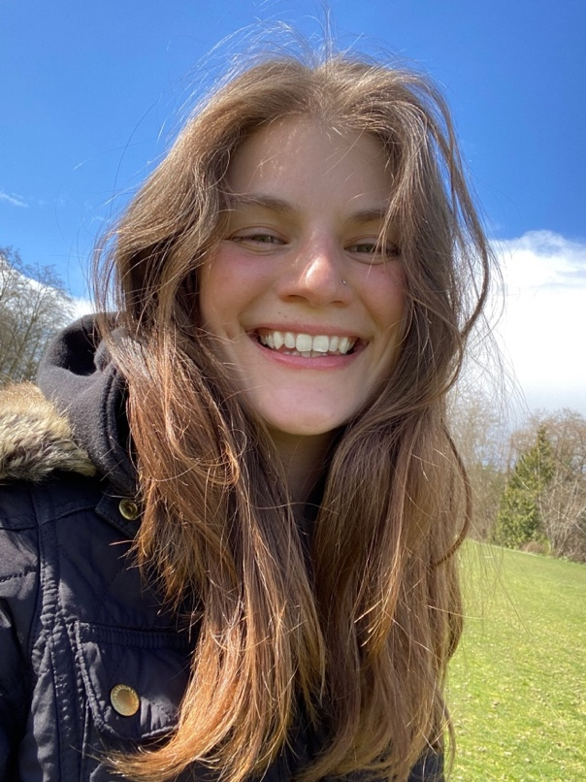

Inside the Studio

The events will happen in the garage and in the Studio space which is located at the end of the hallway.

The garage is at the front of the building.

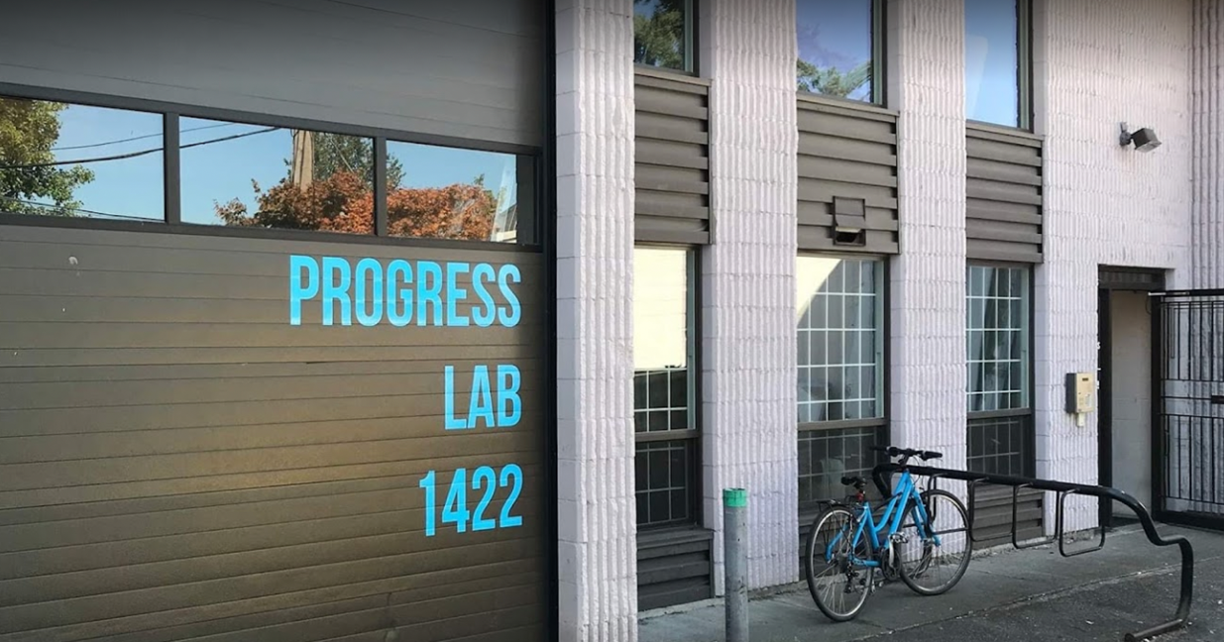

This is what the Studio space looks like inside.

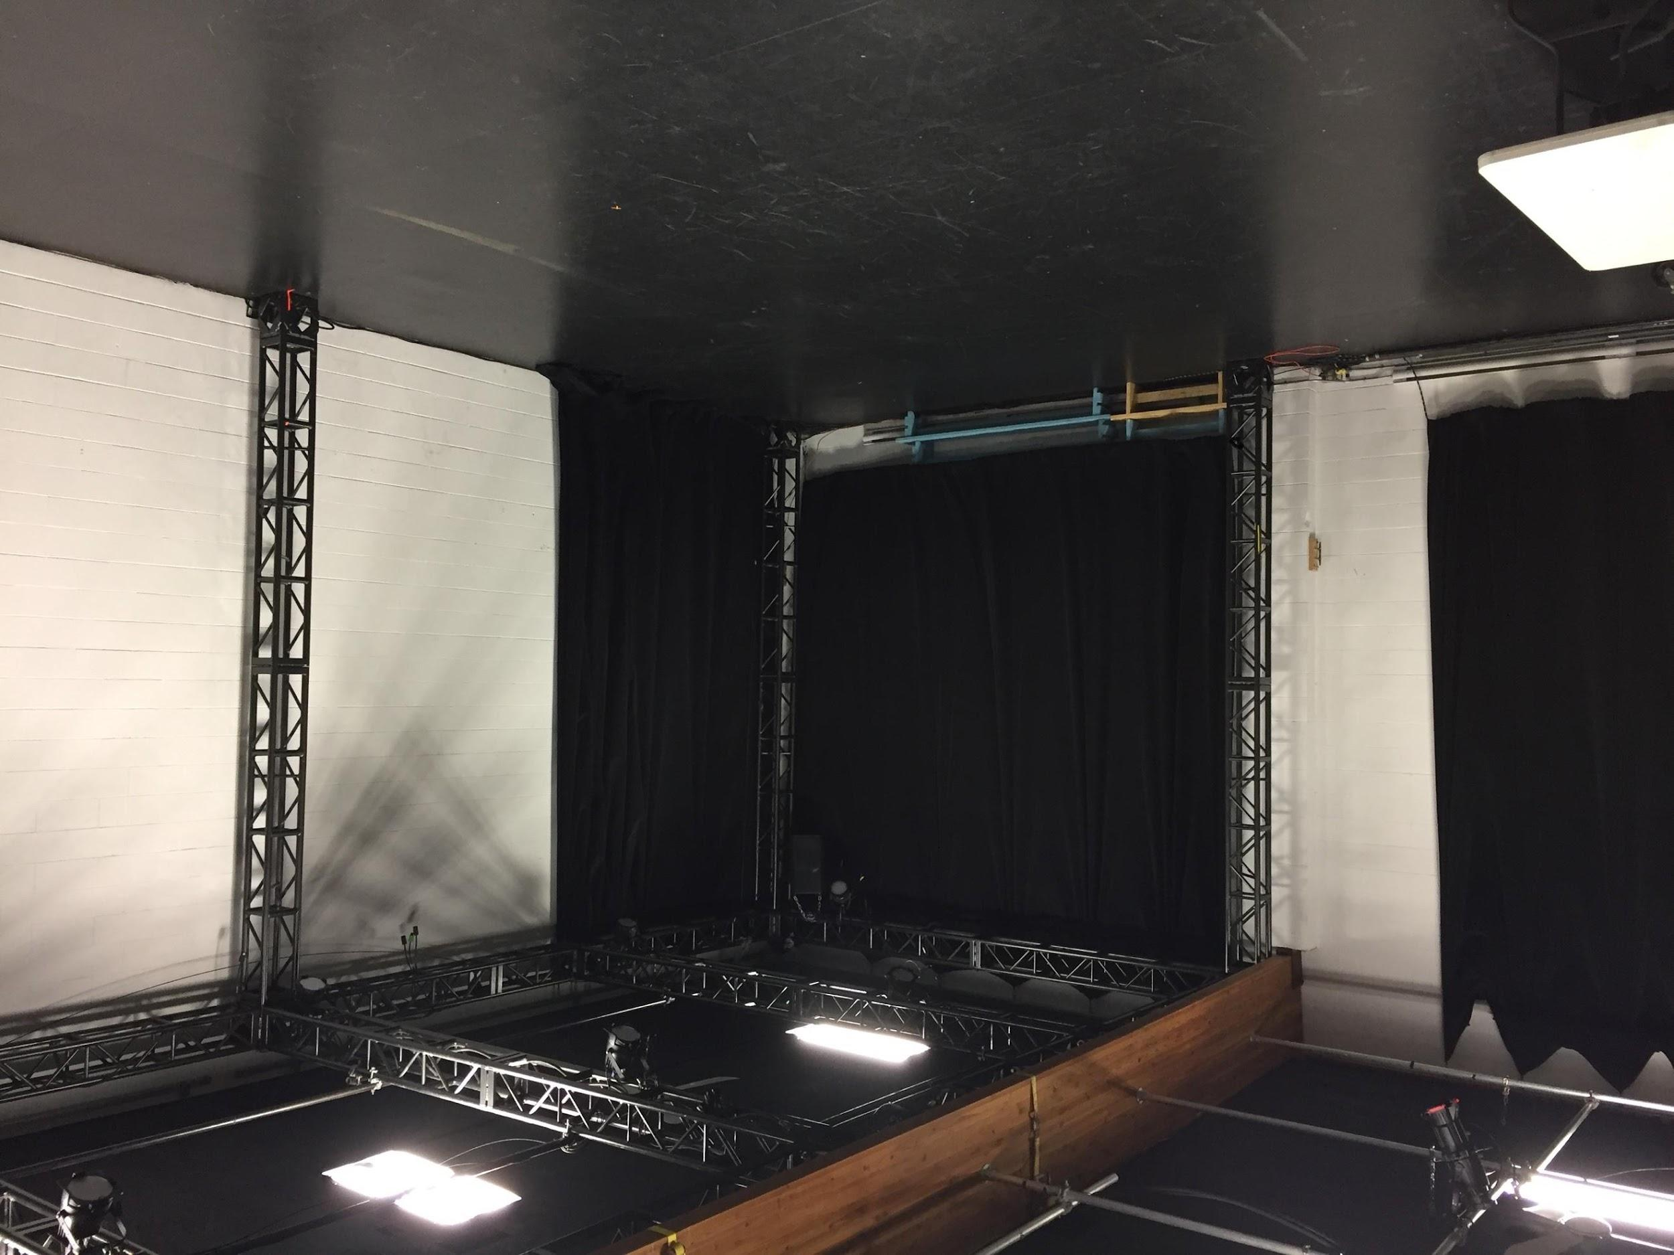

- Washrooms

In the hallway, there are three washrooms.

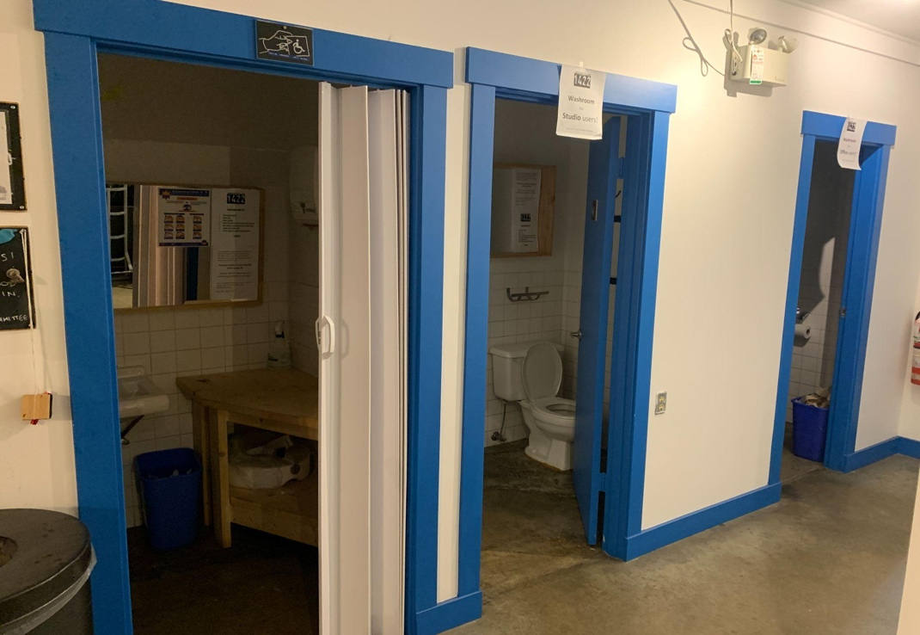

The one on the far left is an accessible washroom. All three washrooms are gender neutral.

This Visual story is based on one originally created by Neworld Theatre for the LEAD Ensemble, we thank them for their support.

